**“ONLINE PAYMENT”**

A Project Report

Submitted in partial fulfilment of the

Requirements for the

**Award of the Degree of**

**BACHELOR OF SCIENCE (INFORMATION TECHNOLOGY)**

**By**

**SHABBO SHAIKH**

**3027489**

Under the esteemed

Guidance of

**Mr. Wendrich Soares**

**H.O.D of IT**

**DEPARTMENT OF INFORMATION TECHNOLOGY**



**Vedanta College**

**(Affiliated to University of Mumbai)**

**VITHALWADI,**

**421-003**

**MAHARASHTRA**

**2024-2025**

 **VEDANTA COLLEG,**

**VITHALWADI,**

**CERTIFICATE**

This is to certify that the project entitled**, “ONLINE PAYMENT”,** is

Bonafide work of

**SHABBO SHAIKH, bearing Seat No. :-**

**3027489** submitted in partial fulfilment of therequirements

For the award of degree in **BACHELOR OF SCIENCE IN**

**INFORMATION TECHNOLOGY** from **University of Mumbai.**

**Co-ordinator**

**Internal Guide**

**External Examiner**

**DECLARATION**

I hereby declare that the project entitled, “**ONLINE PAYMENT**”

done by **Mumbai University, Mumbai**, has not been in any case duplicated to submit to any other University for the award of any degree. To the best of my knowledge other than me, no one has submitted to any other University.

The project is done in partial fulfilment of the requirements for the award of degree of **BACHELOR OF SCIENCE(INFORMATION TECHNOLOGY)** to be submitted as final

semester project as part of our Curriculum.

**Shabbo Shaikh**

**ACKNOWLEDGEMENT**

I would like to express my sincere gratitude to my project guide, [**WENDRICH SOARES**], for their valuable guidance, encouragement, and support throughout the project. I also thank my faculty members, friends, and family for their continuous support in completing this project successfully.

I wish to express my sincere thanks to many persons who

Also thank my faculty members, friends, and family for their continuous support in completing this project successfully.helped me to develop the project.

I express my gratitude to all members of teaching and non-

teaching staff of the Department of Information Technology

for their co-operation during the verification of the project.

**ABSTRACT**

Online payment has revolutionized the way transactions are conducted, offering convenience, security, and efficiency. This project explores the evolution of online payment systems, their technological foundation, security challenges, and future trends. The report also highlights the role of encryption, payment gateways, and fraud prevention techniques to ensure secure digital transactions.The study was conducted In Mumbai region and the survey was collected through a structured questionnaire.

A Descriptive study was conducted through which 111 responses was collected. The paper also Shows the steps taken by RBI and the Government to encourage cashless society in India i.e the Government introduced BHIM and UPI. Cashless transactions like transactions through e-wallets, have various benefits like reduction in black money, reduction in crime rates, helps in Improving economic growth of the country, helps in fighting against terrorism, attract more.

Foreign investors, but this also comes with various disadvantages like the major issue at the Moment is the security of the transactions and the services offered in these online payment Applications. This paper studies the impact of online payment applications on consumers whether Consumer are satisfied using online payment application or not.

**TABLE OF CONTENT**

|  |  |  |
| --- | --- | --- |
| **Chapter No.** | **Content** | **Page No.** |
|  | Abstract |  |
| **1.** | **Introduction** |  |
|  | * 1. What is online payment?   2. Importance of online payment |  |
| **2.** | **Literature Review**  2.1 Evaluation of online payment system |  |
| **3.** | **Types Of Online Payment System**  3.1 Credit & debit card payments  3.2 Digital wallet  3.3 UPI based payment  3.4 Net - banking |  |
| **4.** | **Technologies Behind Online Payment**  4.1 Encryption & security protocol  4.2 Payment Gateway  4.3 Role of blockchain & Cryptocurrency |  |
| **5.** | **Implementation Code** |  |
| **6.** | **Security Challenges & Solution**  6.1 Common security threats  6.2 Security measures |  |
| **7.** | **Advantage**  **&**  **Disadvantage** |  |
| **8.** | **Conclusion & Suggestions** |  |
| **9.** | **Reference** |  |

**CHAPTER NO. 1:- INTRODUCTION**

**Introduction**

In today’s digital era, online payment systems have revolutionized the way people conduct financial transactions. With the increasing demand for cashless transactions, online payment systems provide a fast, secure, and convenient method of transferring money.

Online payment refers to the electronic transfer of money over the internet for purchasing goods and services. With advancements in digital banking, online payment methods have become an essential part of e-commerce and financial transactions worldwide.

Now-a-days world is becoming digitalized in every field and one of the best example of this is various countries in the world are moving towards becoming a cashless society.

A cashless society is the one which doesn‟t use cash for any of its transaction instead all the transactions are Done digitally. There are various countries in the world which have more than 50% of their Transactions through cashless methods.According to a study conducted by Capgemini and BNP Paribas, digital payments are expected To reach about 726 billion transactions by the year 2020. In India 98% of the total transactions.

Used to be done through cash but after the Demonetization of the Government on Nov 8 2016, Our country has also started getting steered towards a cashless society. Due to the Demonetization act already existing mobile payment applications came into the limelight like Paytm, Google pay, Phone Pe etc.

The Digital India program is a flagship agenda of the Government of India with vision to Transform India into a digitally empowered society and a knowledge economy. “Faceless, Paperless, Cashless is one of the professed role of Digital India. The Prime Minister of India Mr. Narendra Modi has empowered India to adopt cashless transactions by giving digital payments Sector of India a significant boost. The digital payment sector of India experienced a unpredicted

Growth since Demonetization in November 2016. Digital wallet companies in India has shown a Growth of 271% for a total value of US$2.8 Billion i.e Rs 191 crores. A Google- BCG Report. Had estimated that the digital payment industry in India will experience a growth of US $ 500 Billion by 2020.

**1.1What is online payment?**

Online payment refers to the electronic transfer of money over the internet for purchasing goods and services. With advancements in digital banking, online payment methods have become an essential part of e-commerce and financial transactions worldwide.

Digital Payment means when any goods or services are purchased through the use of various. Electronic modes of payments which means there is no use of physical cash or cheques in digital Payment. Now-a-days people use Digital Payments more is because Digital payment methods are easier and more convenient and they also provide customers the flexibility to make the payment From anywhere at any time.

Online payment refers to the electronic transfer of funds via the internet, typically between a merchant and a consumer, using methods like credit/debit cards, banking apps, or digital wallets.

When it comes to knowing online payment meaning, in essence it is an exchange of currency, electronically through the internet. The process in these payments is the transfer of money from the bank account, debit card, or credit card of a customer to the bank account of a seller. This online e-payment is handy for purchasing the merchandise or services of sellers.

Buyers and sellers make online transactions with the help of online payment apps. On the buyers’ side, the transaction is to purchase goods and services and products or services deliverance from the sellers’ end. These easy online payment options involve several steps while transferring a buyer’s funds and seller’s offerings. Both parties will use some online payment apps to complete their transactions successfully.

**1.2 Importance of online payment**

Online payments are important because they offer speed, convenience, security, and cost-effectiveness, making them a preferred choice for both businesses and consumers, especially in the digital age.

Provides convenience for users to make transactions from anywhere.Reduces dependency on cash and minimizes physical contact. Enhances security through encryption and authentication technologies.Facilitates fast and efficient financial transactions globally.

E-payments are crucial for modern economies as they offer speed, convenience, and efficiency, boosting financial inclusion, reducing costs, and streamlining transactions for both businesses and individuals.

One of the primary advantages of online payment is the convenience it provides. Users can make transactions from anywhere, at any time, without the need to visit a physical store or bank. This ease of access is particularly beneficial for:

* Customers who prefer shopping online without geographical constraints.
* Businesses that want to offer multiple payment options to their clients.
* Individuals who need to transfer money quickly to family, friends, or service providers.
* The availability of mobile payment solutions, such as digital wallets (**e.g.**, Google Pay, Apple Pay, PayPal), has further enhanced convenience, allowing users to complete transactions with just a few taps on their smartphones.

**CHAPTER NO. 2:-Literature Review**

**Literature Review**

**2.1 Evolution of Online Payment Systems:-**

A review of literature on online payment systems reveals their crucial role in e-commerce, highlighting advancements, benefits, and challenges, including security concerns and the need for secure and user-friendly systems.

1.n the 1990s, online payments were introduced with the rise of e-commerce.

2.arly 2000s saw the emergence of digital wallets like PayPal, 2010s marked the rise of mobile payments, UPI, and cryptocurrency.

3.urrent trends involve AI-driven fraud detection and blockchain-based payments.

**1) According to Mamta, Prof. Hariom Tyagi and Dr. Abhishek Shukla(2016):-**The article entitled “The Study of Electronic Payment Systems”. This study aims to identify the issues and challenges of electronic payment system and offer some solutions to improve the e-payment quality. The successful implementation of electronic payment system depends on how the security and privacy dimensions perceived by consumers as well as sellers are popularly managed in turn would improve the market confidence in system.

**2) According to Sujith T S, Julie C D(2017) :-**The article entitled “Opportunities and Challenges of E-Payment System in India”. This study aimed to identify the issues and challenges of electronic payment systems and offer some solutions to improve the e-payment system. E-Payment system not only provides more opportunities but many threats also. The study found that, the reach of mobile network, Internet and electricity is also expanding digital payments to remote areas. This will surely increase the number of digital payments.

**3) According to Sanghita Roy and Dr. Indrajit Sinha (2014):-**

The article entitled “Determinants of Customer’s Acceptance of Electronic Payment system in Indian Banking sector”. The objective of the study was finding out the most popular electronic payment system among the various payment options. This study also analyzed the level of awareness and the usage of E-payment technologies. The main aim of the study was to determine all the factors influencing the customer’s adoption with Technology acceptance model. The study was based on primary data. The data was collected through a structured questionnaire by means of survey and also focused on a group of 30 respondents. The result of this study was 4 Factors which contribute towards the strengthening the E-payment system in India and those are- Innovation, Incentive, Customer convenience and Legal framework.

**4) According to Prof. Sana Khan and Ms. Shreya Jain (2018):-**This research titled “A Study on Usage of E-payments for Sustainable Growth of Online Business” focuses on the on the frequency and the problems faced by consumers while Using online payment methods. The researchers also examined the effect of e-payments Contribution towards the sustainability of the business growth in India, these were the Main objectives of this research paper. The research conducted is a descriptive research And the primary data was collected through a structured questionnaire send to users of e-Payment methods and the sample size was 100 participants which was collected random Sampling technique. The tools used in this research was Pivot tables and frequency. The Findings of this research suggested that the users of e-payments have increased and it has Become more popular and that majority of the users used online payments because of Coupons and discounts in those transactions.

**5)According to Rachna and Priyanka Singh (2013):-**The research paper titled “Issues and Challenges of Electronic payment systems” aims to identify the issues and challenges faced while using electronic payment systems and this paper also offer some solutions to improve the quality of e-payment system. This paper stated some issues such as lack of security, lack of trust in such payment services by the consumers, lack of awareness by the consumers, online payment services are not feasible in rural areas of our country. This paper also stated some of the measures to handle those problems such as encryption, digital signature, firewalls, and can request for more identification in case of any doubts. The paper concluded with the facts that e-payment systems can be successful if the privacy of the consumers and the security dimensions are well managed which would increase the confidence of the customers on such payment applications.

**6) According to N Ramya, D Sivasakthi and Dr. M Nandhini (2017):-**The research paper titled “Cashless transactions: Modes, advantages and Disadvantages” focuses on to state the efforts by the RBI and the Government of India to promote the digital modes of payments and to achieve the goal of a „less cash society‟. The researcher also studied the various modes of cashless transactions such as e-wallets, mobile wallets, UPI apps, AEPS, USSD system, debit/credit cards for payments. This researcher also provided various advantages of using cashless modes of payments such as- convenience, tracking the expenditures, avail various discounts, lower risk, and can pay small denominations etc. This research paper also stated certain disadvantages of going cashless and those are- overspending increases, difficult for people who are not used to such technology, losing phone can be problematic, higher risk of identity theft and hacking consumers data etc.

**CHAPTER NO.3:-Types of online payment**

**Types of online payment**

1. **Types of Digital Payment methods in India:-**

1. Banking Cards- Debit/Credit / Prepaid Cards.

2. Digital Wallets.

3. UPI Mobile (Unified Payments Interface).

4. Internet Banking.

5. Mobile Banking.

6. BHIM App (Bharat Interface for Money).

**3.1 Credit & Debit Card Payments:-**

Users can make payments using Visa, MasterCard, or RuPay cards via payment gateways.

Credit and debit card payments are cashless methods, where a debit card directly deducts funds from your bank account, while a credit card allows you to borrow money from a financial institution to pay later, with potential interest charges if not paid within a grace period.

* You are borrowing money to pay for whatever you are purchasing with a credit card. The payment is due at the end of the month, and if you cannot make the whole payment, you are charged interest for borrowing the money you can’t pay back. A credit card is essentially a revolving loan.
* You use the credit card to make purchases and then pay back the amount later, usually within a specified period (like a monthly bill).



* When you use a debit card, the amount of your purchase is immediately deducted from your linked bank account (like a checking or savings account).
* .Debit cards deduct money directly from your bank account, while credit cards allow you to borrow money and pay later.

* When you use a debit card, the money is immediately deducted from your bank account.



**3.2 Digital Wallets:-**

* Apps like Google Pay, Paytm, and Apple Pay store card details for quick transactions.
* A digital wallet, also known as an e-wallet or mobile wallet, is a software application or online service that stores payment information and allows users to make electronic transactions, eliminating the need for physical cash or cards.
* It allows you to make payments online or at physical stores using your smartphone or other connected devices.

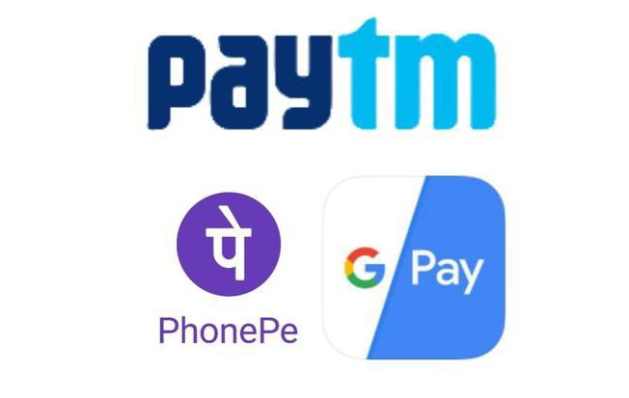

**3.3 UPI-Based Payments:-**

* Unified Payments Interface (UPI) allows instant fund transfers between bank accounts.
* UPI (Unified Payments Interface) is a real-time payment system in India that allows instant money transfers between bank accounts via a mobile application, simplifying digital payments and promoting financial inclusion.



**3.4 Net Banking:-**

* Direct payments through bank websites without third-party involvement.
* Net banking, also known as online banking, is a digital banking service provided by banks that allows customers to perform financial transactions over the internet.
* Users need to log in to their bank’s website using a user ID and password.
* Uses encryption, OTP authentication, and secure login credentials.

**3.5 Mobile Banking:-**

* Mobile banking is a banking service provided via a mobile app, enabling customers to perform financial transactions using their smartphones.
* Fund transfers, mobile recharges, bill payments, UPI payments, and loan management**.**
* Requires downloading the bank’s mobile app and logging in with credentials or biometric authentication.
* Uses OTP verification, fingerprint authentication, and app-specific passwords.

**3.6 BHIM App (Bharat Interface for Money):-**

* BHIM is a mobile payment application developed by NPCI (National Payments Corporation of India) that uses the Unified Payments Interface (UPI) for transactions.
* Requires a smartphone, a registered mobile number linked to a bank account, and UPI PIN setup.
* .Uses device binding, UPI PIN, and biometric authentication for secure transactions.



**CHAPTER NO.4:- Technologies Behind Online Payment**

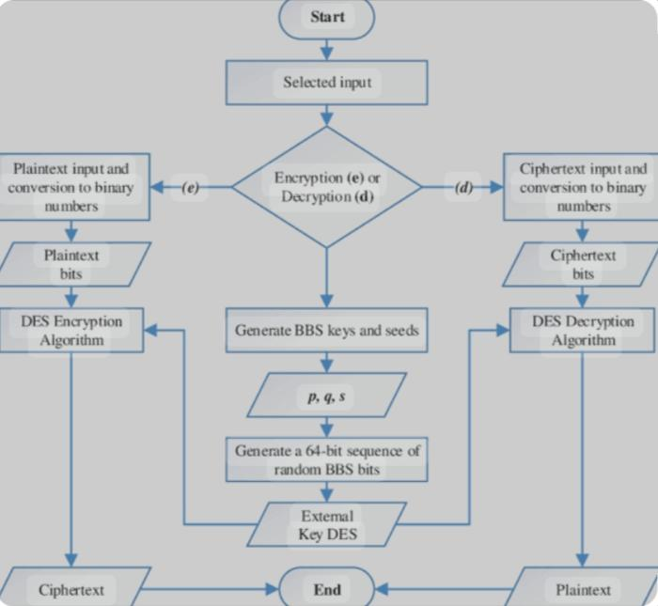

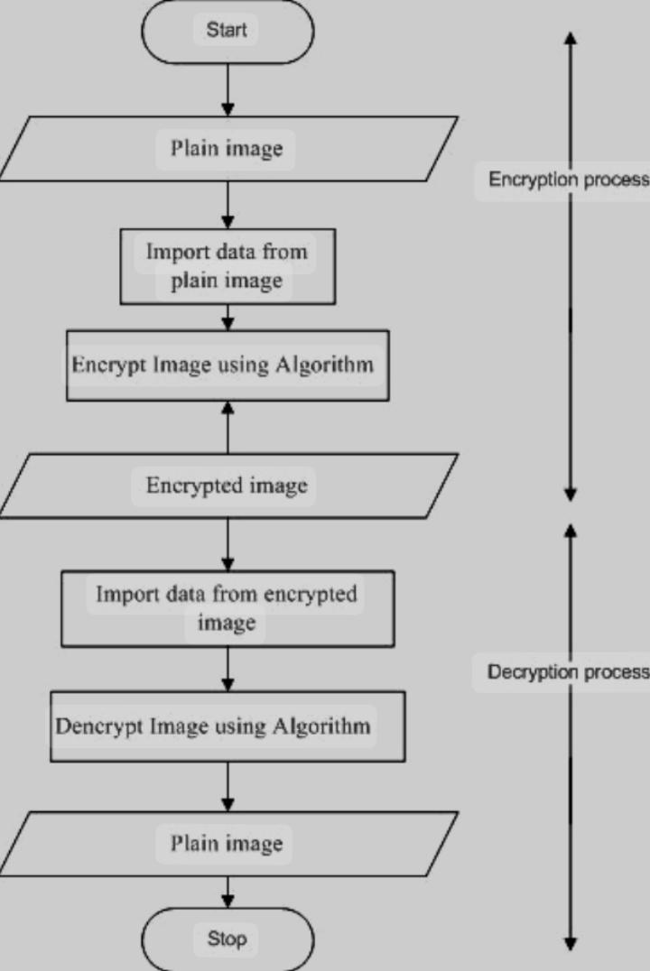

**4.1 Encryption & Security Protocols:-**

**SSL/TLS Encryption:** Ensures data security during transactions.

**End-to-End Encryption:** Protects sensitive payment information.

**4.2 Payment Gateways:-**

Services like Razorpay, Stripe, and PayPal act as intermediaries between customers and merchants.

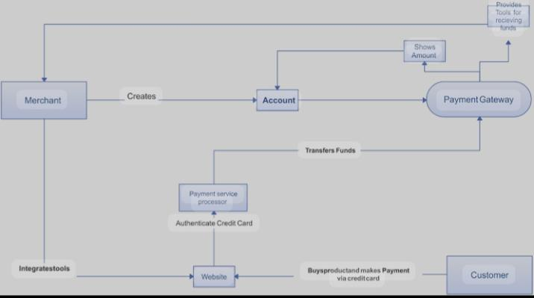

**4.3 Role of Blockchain & Cryptocurrencies:-**

Decentralized systems like Bitcoin and Ethereum enhance transaction security. Cryptocurrencies are usually built using blockchain technology.

Blockchain describes the way transactions are recorded into "blocks" and time stamped. It's a fairly complex, technical process, but the result is a digital ledger of cryptocurrency transactions that's hard for hackers.

Bitcoin, Ethereum, and other popular cryptocurrency coins use blockchain to process and record transactions securely. This technology makes it possible to ensure transparency and protect the financial information and identity of crypto buyers and sellers.

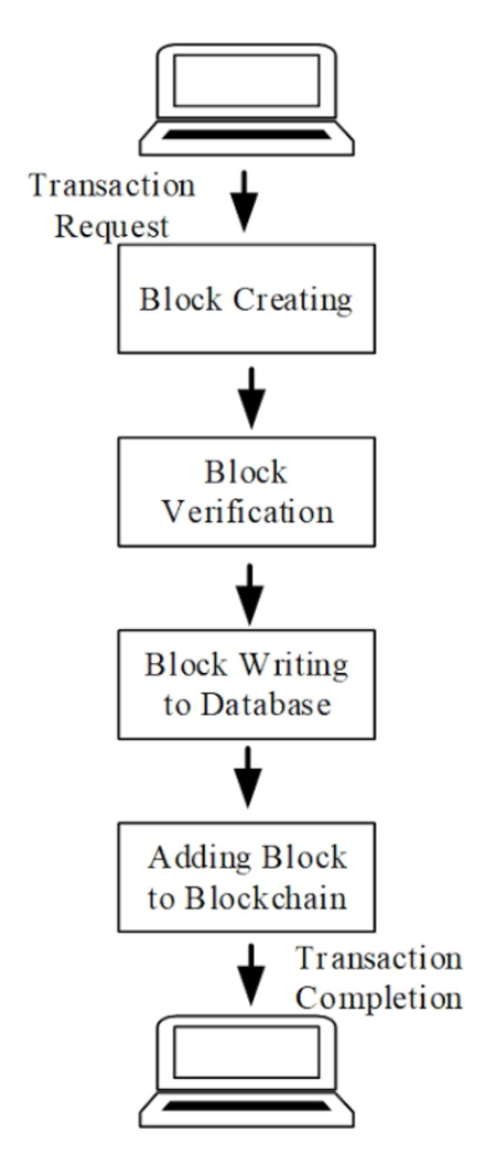

**CHAPTER NO. 5:- Implementation code**

**Login process:-**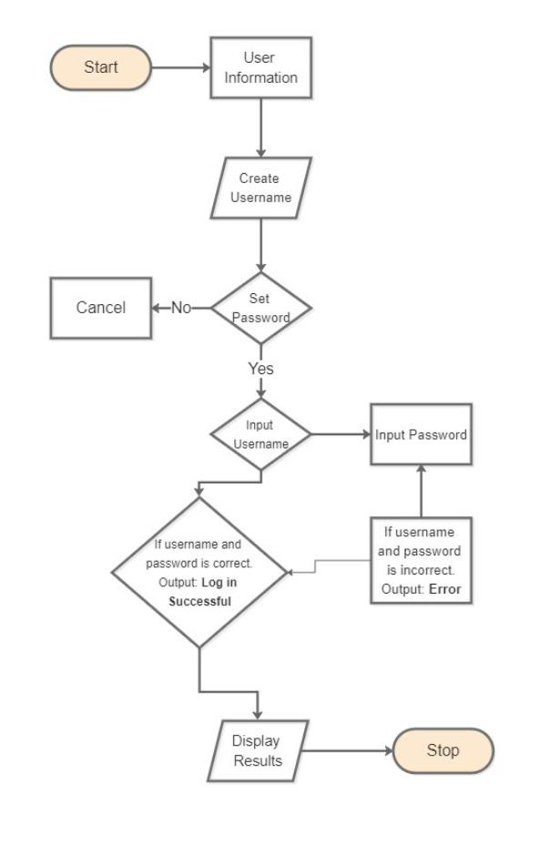

**Index. Html**

<!DOCTYPE html>

<html>

<head>

<title>QuickPay - Online Payment</title>

</head>

<body>

<h2>Online Payment Form</h2>

<form action="submit_payment.php" method="post">

<label>Name on Card:</label><br>

<input type="text" name="cardname"><br><br>

<label>Card Number:</label><br>

<input type="text" name="cardnumber"><br><br>

<label>Expiry Date:</label><br>

<input type="text" name="expiry"><br><br>

<label>CVV:</label><br>

<input type="password" name="cvv"><br><br>

<input type="submit" value="Pay Now">

</form>

</body>

</html>

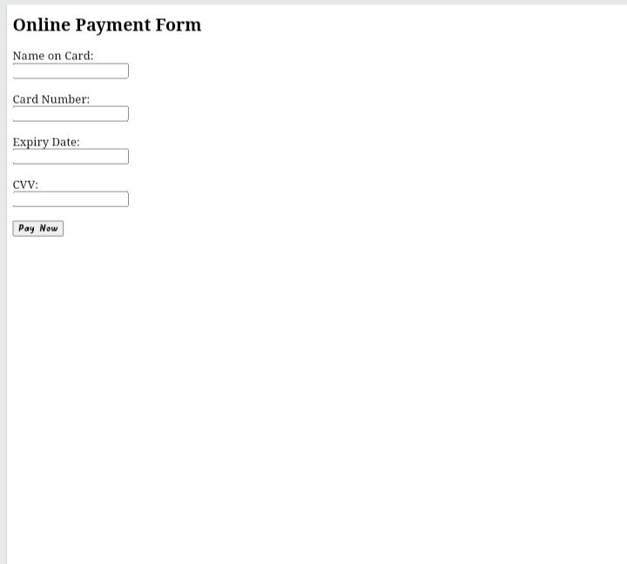**OUTPUT:-**

**Python. py**

Import stripe

Stripe.api_key = “your_secret_key”

Payment_intent = stripe.PaymentIntent.create(

Amount=1000,

Currency=’usd’,

Payment_method_types=[‘card’],

)

Print(“Payment Initiated: “, payment_intent.id)

def process_payment(card_number, amount):

if len(card_number) == 16 and amount > 0:

return "Payment Successful"

else:

return "Payment Failed"

card = "1234567812345678"

amount = 50

****print(process_payment(card, amount**))**

**index.html – Home Page**

<!DOCTYPE html>

<html>

<head>

<title>QuickPay - Home</title>

</head>

<body>

<h1>Welcome to QuickPay</h1>

<p>Your trusted online payment partner.</p>

<a href="login.html">Login to Pay</a>

</body>

</html>

**Login.html – User Login**

<!DOCTYPE html>

<html>

<head>

<title>QuickPay – Login</title>

</head>

<body>

<h2>Login</h2>

<form action=”payment.html” method=”get”>

Username: <input type=”text” name=”username”><br><br>

Password: <input type=”password” name=”password”><br><br>

<input type=”submit” value=”Login”>

</form>

</body>

</html>

**payment.html – Payment Page**

<!DOCTYPE html>

<html>

<head>

<title>QuickPay - Payment</title>

</head>

<body>

<h2>Payment Form</h2>

<form action="success.html" method="get">

Card Number: <input type="text" name="cardnumber"><br><br>

Expiry Date: <input type="text" name="expiry"><br><br>

CVV: <input type="password" name="cvv"><br><br>

<input type="submit" value="Pay Now">

</form>

</body>

</html>

**success.html – Payment Confirmation**

<!DOCTYPE html>

<html>

<head>

<title>QuickPay - Success</title>

</head>

<body>

<h2>Payment Successful!</h2>

<p>Thank you for using QuickPay.</p>

</body>

</html>

**Cpp**

**C++**

#include <iostream>

#include <string>

using namespace std;

bool validateCard(string cardNumber, string cvv) {

return (cardNumber.length() == 16 && cvv.length() == 3);

}

void processPayment(float amount, string cardNumber, string cvv) {

if (validateCard(cardNumber, cvv)) {

cout << "Payment of ₹" << amount << " processed successfully." << endl;

} else {

cout << "Invalid card details. Payment failed." << endl;

}

}

int main() {

float amount = 500.00;

string cardNumber = "1234567890123456";

string cvv = "123";

processPayment(amount, cardNumber, cvv);

return 0;

}

**OUTPUT:-**

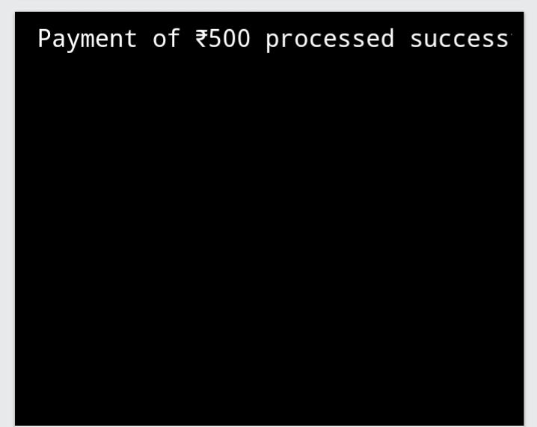

**Index. Php**

<!DOCTYPE html>

<html>

<head>

<title>Online Payment</title>

</head>

<body>

<h2>Make a Payment</h2>

<form action=”process_payment.php” method=”post”>

<label>Name:</label>

<input type=”text” name=”name” required><br><br>

<label>Email:</label>

<input type=”email” name=”email” required><br><br>

<label>Amount (INR):</label>

<input type=”number” name=”amount” required><br><br>

<label>Card Number:</label>

<input type=”text” name=”card” maxlength=”16” required><br><br>

<label>Expiry (MM/YY):</label>

<input type=”text” name=”expiry” required><br><br>

<label>CVV:</label>

<input type=”password” name=”cvv” maxlength=”3” required><br><br>

<input type=”submit” value=”Pay Now”>

</form>

</body>

</html>

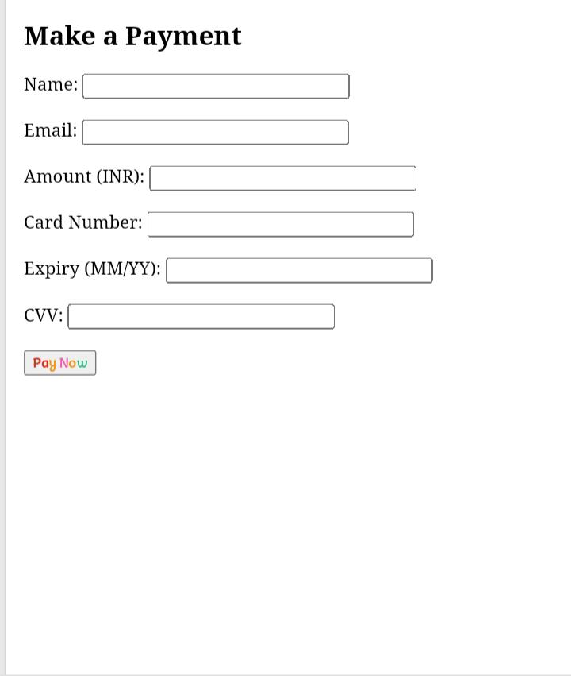**Output:-**

**process_payment.php**

<?php

If ($_SERVER[“REQUEST_METHOD”] == “POST”) {

// Collect form data

$name = $_POST[‘name’];

$email = $_POST[‘email’];

$amount = $_POST[‘amount’];

$card = $_POST[‘card’];

$expiry = $_POST[‘expiry’];

$cvv = $_POST[‘cvv’];

// Simulate payment success (in real app, connect to payment gateway like Razorpay, Stripe, etc.)

$transaction_id = uniqid(‘txn_’);

$status = “Success”;

$date = date(“Y-m-d H:i:s”);

// Store payment info in a text file (or ideally, in a database)

$record = “$transaction_id | $name | $email | ₹$amount | $status | $date\n”;

File_put_contents(“payments.txt”, $record, FILE_APPEND);

Echo “<h3>Payment Successful!</h3>”;

Echo “Transaction ID: $transaction_id<br>”;

Echo “Amount Paid: ₹$amount<br>”;

Echo “Status: $status<br>”;

Echo “Date: $date<br>”;

} else {

Echo “Invalid request.”;

}

?>

**Output:-**

**CHAPTER NO. 6:-SECURITY CHALLENGES & SOLUTIONS**

**6.1 Common Security Threats**

* **Phishing Attacks:** Fake websites trick users into revealing credentials.Phishing is a cyber-attack where fraudsters disguise themselves as legitimate entities to trick users into providing sensitive information like passwords, credit card numbers, or banking details. These attacks are typically conducted through fake emails, messages, or websites that appear genuine.

**Phishing Email Detection in Python**

import re

def detect_phishing(email_content):

phishing_keywords = ["urgent", "verify your account", "click here", "reset password"]

for keyword in phishing_keywords:

if re.search(keyword, email_content, re.IGNORECASE):

return "Potential Phishing Email Detected"

return "Email Seems Safe"

email_text = "Dear User, please click here to verify your account urgently."

print(detect_phishing(email_text))

* **Fraudulent Transactions:**

Unauthorized access to payment details. Fraudulent transactions occur when cybercriminals use stolen or fake credentials to make unauthorized purchases. These transactions can lead to financial losses for businesses and users.

**Detecting Fraudulent Transactions with Machine Learning**

from sklearn.ensemble import IsolationForest

import numpy as np

# Simulated transaction data (amounts)

data = np.array([[50], [20], [15], [1000], [30], [5], [2000]])

model = IsolationForest(contamination=0.2)

model.fit(data)

# Predict anomalies (fraudulent transactions)

predictions = model.predict(data)

print("Transaction Fraud Detection: ", predictions)

* **Data Breaches:** Hackers steal financial information from payment servers. A data breach occurs when unauthorized individuals gain access to sensitive financial and personal information. This can happen due to weak security protocols, insider threats, or hacking attacks. Data breaches can lead to identity theft, financial fraud, and loss of customer trust.

Securing User Data Using Encryption

from cryptography.fernet import Fernet

# Generate encryption key

key = Fernet.generate_key()

cipher_suite = Fernet(key)

# Secure user data

user_data = "UserID: 12345, Card: 9876-5432-1098-7654"

encrypted_data = cipher_suite.encrypt(user_data.encode())

print("Encrypted User Data:", encrypted_data)

**6.2 Security Measures**

**Two-Factor Authentication (2FA):** Adds an extra security layer.

**AI-Based Fraud Detection:** Monitors transaction patterns for suspicious activities.

**Biometric Authentication:** Uses fingerprints and facial recognition for secure access.

**Secure Hashing for Payments**

Import hashlib

Def hash_payment_details(payment_info):

Return hashlib.sha256(payment_info.encode()).hexdigest()

Payment_data = “User1234:Card5678”

Hashed_data = hash_payment_details(payment_data)

Print(“Secure Payment Data: “, hashed_data)

**Encrypting Payment Data with Python**

From cryptography.fernet import Fernet

Key = Fernet.generate_key()

Cipher_suite = Fernet(key)

Payment_info = “CardNumber: 1234567812345678”

Encrypted_data = cipher_suite.encrypt(payment_info.encode())

Print(“Encrypted Payment Info:”, encrypted_data)

**import random**

def generate_otp():

return random.randint(100000, 999999)

otp = generate_otp()

print(f"Your OTP is: {otp}")

user_otp = int(input("Enter OTP: "))

if user_otp == otp:

print("Authentication Successful")

else:

print("Invalid OTP")

**CHAPTER NO.7:- Advantage & Disadvantage**

**7.1 Advantages**

Online payments offer several advantages, including speed, convenience, global reach, and cost-effectiveness, making them a preferred choice for both businesses and individuals. They facilitate faster transactions, are convenient to use, and can reach a global audience, while also reducing costs and improving cash flow.

✅ Fast and convenient transactions.

✅ Reduces reliance on cash.

✅ Enhances security with encryption and authentication.

✅ Promotes financial inclusion globally.

**7.2 Disadvantages**

Online payments offer convenience but also come with disadvantages like fraud risks, security concerns, technical glitches, and reliance on the internet. Additionally, some platforms may charge transaction fees, and there can be limited consumer protection in certain situations.

❌ Risk of cyber fraud and hacking.

❌ Dependence on internet connectivity.

❌ Technical issues may cause transaction failures.

**CONCLUSION**

Online payment systems have significantly improved financial transactions by offering convenience, security, and efficiency.

As technology advances, innovations like blockchain, AI-driven security, and contactless payments will shape the future of digital transactions. While security threats exist, robust authentication methods and fraud detection mechanisms are continuously evolving to mitigate risks.

The advancement of online payment systems has transformed the way transactions are conducted, offering convenience, speed, and efficiency. Technologies like encryption, secure payment gateways, and blockchain have significantly enhanced security and trust in online transactions. However, with these advancements come challenges, including fraud, cyber threats, and data breaches. Implementing strong security measures such as two-factor authentication, secure hashing, and fraud detection algorithms is essential to ensure safe transactions.

Looking ahead, the future of online payments is promising, with innovations such as AI-driven fraud detection, decentralized finance (DeFi), and contactless payment methods. As technology evolves, it is crucial for businesses and individuals to stay informed and adopt best practices to ensure secure and seamless payment experiences.

The continuous Improvements in online payment systems indicate a shift towards a cashless and digitally-driven economy. By addressing security concerns and leveraging new technologies, online payments will continue to shape the future of financial transactions worldwide.

**Suggestions:-**

* Many respondents felt that the hindrance in adopting cashless economy is the digital and technological illiteracy among the people of India, so to overcome this problem government need to take initiatives in educating the people about the same.
* As majority of the crowd in our country belong to the rural areas it is very important to educate the people about cashless transaction and about e-wallets.
* Many of the respondents felt that cashless mode of transactions in India is not safe so the government should make electronic payments infrastructure completely safe and secure.
* To increase more digital payments the government should bring transparency and efficiency in the transactions
* The government should conduct a financial literacy campaign to educate the population about the digital modes of payment.
* Government should make the infrastructure capable and secure so that there are minimum fraud and thefts.These are some of the suggestions which can help better implementation of cashless society in India.

**Reference**

1. A Review on Electronic Payments Security

**Author:** Dr. Varalakshmi, Anusuyaa S, Anurag Baheti, Mahak Sethia D

**Published:** 2024

**Summary**: This study focuses on digital payment systems in cybersecurity, highlighting their integral role in modern commerce and the associated security challenges.

**2. Digital Rupee (e₹) –** FAQs

**Organization:** Reserve Bank of India

**Published:** 2025

**Summary:** This document provides frequently asked questions about India's Central Bank Digital Currency (CBDC), the Digital Rupee, including its features and usage.

The RBI's Monetary Policy on Digital Payments

**Organization:** PwC India

**Published:** 2021

**Summary:** This document discusses the Reserve Bank of India's monetary policy concerning digital payments, including interoperability and regulatory guidelines.

Lessons from the **Unified Payments Interface (**UPI)

**Author**: Reserve Bank of India

**Published**: 2025

**Summary**: This document provides insights into the success factors of India’s UPI system and its impact on the country’s payment market.

**1.ChatGPT** (AI-based Reference)

OpenAI. (2025). ChatGPT – AI-powered conversational model. Retrieved from <https://openai.com/chatgpt>

**2. Google Search Results**

Google. (2025). Online Payment Security Measures. Retrieved from <https://www.google.com>

1. W3Schools (For Coding References)

W3Schools. (2025). Python Programming – Payment Processing Code. Retrieved from <https://www.w3schools.com/python>

1. **the Online Sources (if used)**

Example: Wikipedia, Research Papers, RBI Guidelines, etc.

Format: Author (Year). Title. Retrieved from [Website URL]